fNIRS Implementation in Semantic
Memory Recall

An Independent Study
Submitted to the Faculty of
The Department of Electrical and Computer Engineering
Villanova University

By

Brianna Conte

In Partial Fulfillment
Of the Requirements for the Degree of
Bachelor of Science in Electrical Engineering



May 10, 2019

Copyright © 2018 by Paul Davies
All Rights Reserved

Villanova University
Electrical and Computer Engineering Department
UnderGraduate Program

ECE 5991/5992: EE Research I/II

Approval Form

Student’s Name: Brianna Conte

Department: Electrical and Computer Engineering

Title of Independent Study: fNIRS Implementation in Semantic Memory Recall

Date Submitted: May 10th, 2019

Faculty Advisor: Date

Chairperson: Date

Acknowledgement

Lorem ipsum dolor sit amet, consectetuer adipiscing elit. Ut purus elit, vestibulum ut, placerat ac, adipiscing vitae, felis. Curabitur dictum gravida mauris. Nam arcu libero, nonummy eget, consectetuer id, vulputate a, magna. Donec vehicula augue eu neque. Pellentesque habitant morbi tristique senectus et netus et malesuada fames ac turpis egestas. Mauris ut leo. Cras viverra metus rhoncus sem. Nulla et lectus vestibulum urna fringilla ultrices. Phasellus eu tellus sit amet tortor gravida placerat. Integer sapien est, iaculis in, pretium quis, viverra ac, nunc. Praesent eget sem vel leo ultrices bibendum. Aenean faucibus. Morbi dolor nulla, malesuada eu, pulvinar at, mollis ac, nulla. Curabitur auctor semper nulla. Donec varius orci eget risus. Duis nibh mi, congue eu, accumsan eleifend, sagittis quis, diam. Duis eget orci sit amet orci dignissim rutrum.

Abstract

Lorem ipsum dolor sit amet, consectetuer adipiscing elit. Ut purus elit, vestibulum ut, placerat ac, adipiscing vitae, felis. Curabitur dictum gravida mauris. Nam arcu libero, nonummy eget, consectetuer id, vulputate a, magna. Donec vehicula augue eu neque. Pellentesque habitant morbi tristique senectus et netus et malesuada fames ac turpis egestas. Mauris ut leo. Cras viverra metus rhoncus sem. Nulla et lectus vestibulum urna fringilla ultrices. Phasellus eu tellus sit amet tortor gravida placerat. Integer sapien est, iaculis in, pretium quis, viverra ac, nunc. Praesent eget sem vel leo ultrices bibendum. Aenean faucibus. Morbi dolor nulla, malesuada eu, pulvinar at, mollis ac, nulla. Curabitur auctor semper nulla. Donec varius orci eget risus. Duis nibh mi, congue eu, accumsan eleifend, sagittis quis, diam. Duis eget orci sit amet orci dignissim rutrum.

Contents

Acknowledgment iv
Abstract v
1 Introduction 1
2 Literature Review 1
3 Methodology 3
3.1 Subjects . . . . . . . . . 3
3.3 Procedure . . . . . . . . . 4
4 Results 6
5 Conclusion 9

List of Figures

1.1 The absorbances of Hb ad HbO2 in the optical window. . . . 2

1.2 The fNIRS device is present on the left. On the right, the areas of the brain
measured by the fNIRS headband are highlighted in red. . . . 3

2.1 From top left to right: a) baseline without box present, b) baseline with box
present, c) high agreement line drawing, d) low agreement line drawing. . 4

Chapter 1

Introduction

Lorem ipsum dolor sit amet, consectetuer adipiscing elit. Ut purus elit, vestibulum ut, placerat ac, adipiscing vitae, felis. Curabitur dictum gravida mauris. Nam arcu libero, nonummy eget, consectetuer id, vulputate a, magna. Donec vehicula augue eu neque. Pellentesque habitant morbi tristique senectus et netus et malesuada fames ac turpis egestas. Mauris ut leo. Cras viverra metus rhoncus sem. Nulla et lectus vestibulum urna fringilla ultrices. Phasellus eu tellus sit amet tortor gravida placerat. Integer sapien est, iaculis in, pretium quis, viverra ac, nunc. Praesent eget sem vel leo ultrices bibendum. Aenean faucibus. Morbi dolor nulla, malesuada eu, pulvinar at, mollis ac, nulla. Curabitur auctor semper nulla. Donec varius orci eget risus. Duis nibh mi, congue eu, accumsan eleifend, sagittis quis, diam. Duis eget orci sit amet orci dignissim rutrum.

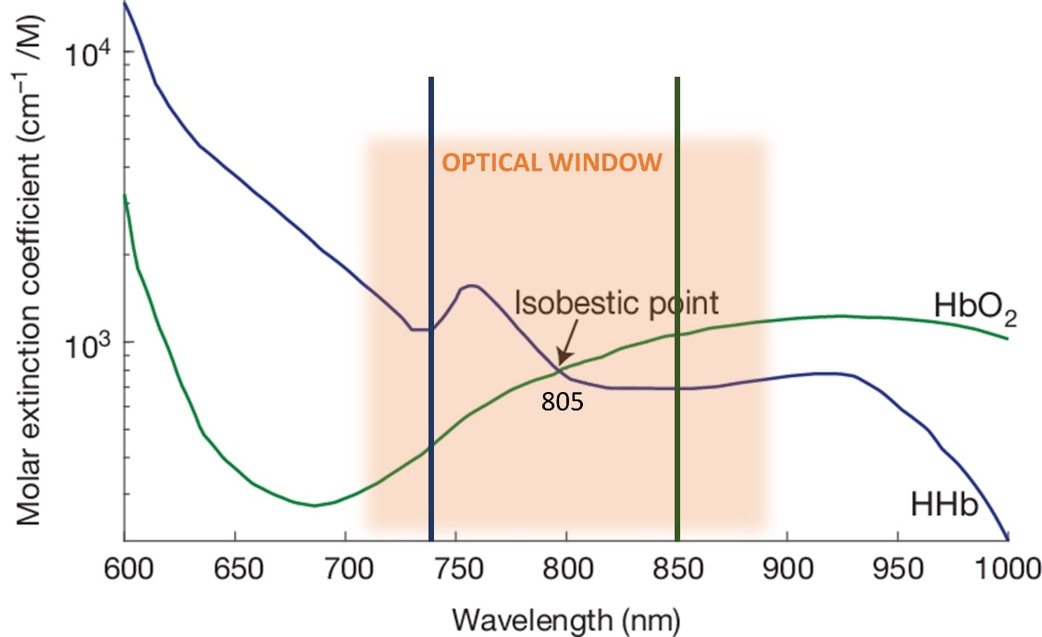
Figure 1.1: The absorbances of Hb ad HbO2 in the optical window.

Chapter 2

Literature Review

2.1 Studies on Semantic Memory

Lorem ipsum dolor sit amet, consectetuer adipiscing elit. Ut purus elit, vestibulum ut,
placerat ac, adipiscing vitae, felis. Curabitur dictum gravida mauris. Nam arcu libero,
nonummy eget, consectetuer id, vulputate a, magna. Donec vehicula augue eu neque.
Pellentesque habitant morbi tristique senectus et netus et malesuada fames ac turpis
egestas. Mauris ut leo. Cras viverra metus rhoncus sem. Nulla et lectus vestibulum urna
fringilla ultrices. Phasellus eu tellus sit amet tortor gravida placerat. Integer sapien est,
iaculis in, pretium quis, viverra ac, nunc. Praesent eget sem vel leo ultrices bibendum.
Aenean faucibus. Morbi dolor nulla, malesuada eu, pulvinar at, mollis ac, nulla.
Curabitur auctor semper nulla. Donec varius orci eget risus. Duis nibh mi, congue eu,
accumsan eleifend, sagittis quis, diam. Duis eget orci sit amet orci dignissim rutrum.

Chapter 3

Materials and Methodology

3.1 Subjects

Lorem ipsum dolor sit amet, consectetuer adipiscing elit. Ut purus elit, vestibulum ut, placerat ac, adipiscing vitae, felis. Curabitur dictum gravida mauris. Nam arcu libero, nonummy eget, consectetuer id, vulputate a, magna. Donec vehicula augue eu neque. Pellentesque habitant morbi tristique senectus et netus et malesuada fames ac turpis egestas. Mauris ut leo. Cras viverra metus rhoncus sem. Nulla et lectus vestibulum urna fringilla ultrices. Phasellus eu tellus sit amet tortor gravida placerat. Integer sapien est, iaculis in, pretium quis, viverra ac, nunc. Praesent eget sem vel leo ultrices bibendum. Aenean faucibus. Morbi dolor nulla, malesuada eu, pulvinar at, mollis ac, nulla. Curabitur auctor semper nulla. Donec varius orci eget risus. Duis nibh mi, congue eu, accumsan eleifend, sagittis quis, diam. Duis eget orci sit amet orci dignissim rutrum.

3.3 Procedure
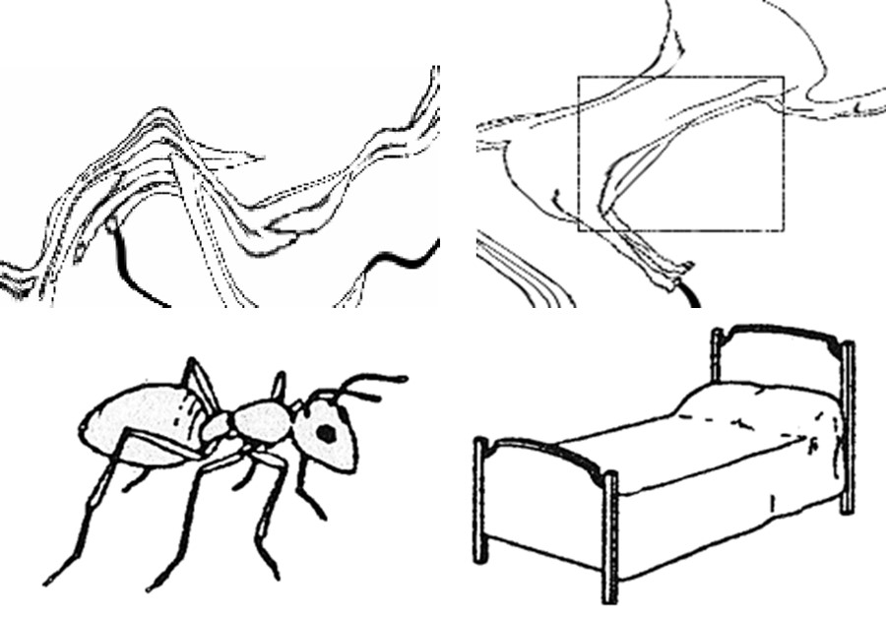
Figure 2.1: From top left to right: a) baseline without box present, b) baseline with box present, c) high agreement line drawing, d) low agreement line drawing.

Lorem ipsum dolor sit amet, consectetuer adipiscing elit. Ut purus elit, vestibulum ut,
placerat ac, adipiscing vitae, felis. Curabitur dictum gravida mauris. Nam arcu libero,
nonummy eget, consectetuer id, vulputate a, magna. Donec vehicula augue eu neque.
Pellentesque habitant morbi tristique senectus et netus et malesuada fames ac turpis
egestas. Mauris ut leo. Cras viverra metus rhoncus sem. Nulla et lectus vestibulum urna
fringilla ultrices. Phasellus eu tellus sit amet tortor gravida placerat. Integer sapien est,
iaculis in, pretium quis, viverra ac, nunc. Praesent eget sem vel leo ultrices bibendum.
Aenean faucibus. Morbi dolor nulla, malesuada eu, pulvinar at, mollis ac, nulla.
Curabitur auctor semper nulla. Donec varius orci eget risus. Duis nibh mi, congue eu,
accumsan eleifend, sagittis quis, diam. Duis eget orci sit amet orci dignissim rutrum.
A total of 192 line drawings were used in the picture naming task, and the drawings were divided into two sets: high name agreement (HA) or low name agreement (LA) on the basis of name agreement norms [2]. Name agreement refers to the proportion of subjects who agreed on the same label for an image. Each picture was presented in a randomized order only once.

Lorem ipsum dolor sit amet, consectetuer adipiscing elit. Ut purus elit, vestibulum ut, placerat ac, adipiscing vitae, felis. Curabitur dictum gravida mauris. Nam arcu libero, nonummy eget, consectetuer id, vulputate a, magna. Donec vehicula augue eu neque. Pellentesque habitant morbi tristique senectus et netus et malesuada fames ac turpis egestas. Mauris ut leo. Cras viverra metus rhoncus sem. Nulla et lectus vestibulum urna fringilla ultrices. Phasellus eu tellus sit amet tortor gravida placerat. Integer sapien est, iaculis in, pretium quis, viverra ac, nunc. Praesent eget sem vel leo ultrices bibendum. Aenean faucibus. Morbi dolor nulla, malesuada eu, pulvinar at, mollis ac, nulla. Curabitur auctor semper nulla. Donec varius orci eget risus. Duis nibh mi, congue eu, accumsan eleifend, sagittis quis, diam. Duis eget orci sit amet orci dignissim rutrum.

Lorem ipsum dolor sit amet, consectetuer adipiscing elit. Ut purus elit, vestibulum ut, placerat ac, adipiscing vitae, felis. Curabitur dictum gravida mauris. Nam arcu libero, nonummy eget, consectetuer id, vulputate a, magna. Donec vehicula augue eu neque. Pellentesque habitant morbi tristique senectus et netus et malesuada fames ac turpis egestas. Mauris ut leo. Cras viverra metus rhoncus sem. Nulla et lectus vestibulum urna fringilla ultrices. Phasellus eu tellus sit amet tortor gravida placerat. Integer sapien est, iaculis in, pretium quis, viverra ac, nunc. Praesent eget sem vel leo ultrices bibendum. Aenean faucibus. Morbi dolor nulla, malesuada eu, pulvinar at, mollis ac, nulla. Curabitur auctor semper nulla. Donec varius orci eget risus. Duis nibh mi, congue eu, accumsan eleifend, sagittis quis, diam. Duis eget orci sit amet orci dignissim rutrum.

Chapter 4

Results

Lorem ipsum dolor sit amet, consectetuer adipiscing elit. Ut purus elit, vestibulum ut, placerat ac, adipiscing vitae, felis. Curabitur dictum gravida mauris. Nam arcu libero, nonummy eget, consectetuer id, vulputate a, magna. Donec vehicula augue eu neque. Pellentesque habitant morbi tristique senectus et netus et malesuada fames ac turpis egestas. Mauris ut leo. Cras viverra metus rhoncus sem. Nulla et lectus vestibulum urna fringilla ultrices. Phasellus eu tellus sit amet tortor gravida placerat. Integer sapien est, iaculis in, pretium quis, viverra ac, nunc. Praesent eget sem vel leo ultrices bibendum. Aenean faucibus. Morbi dolor nulla, malesuada eu, pulvinar at, mollis ac, nulla. Curabitur auctor semper nulla. Donec varius orci eget risus. Duis nibh mi, congue eu, accumsan eleifend, sagittis quis, diam. Duis eget orci sit amet orci dignissim rutrum.

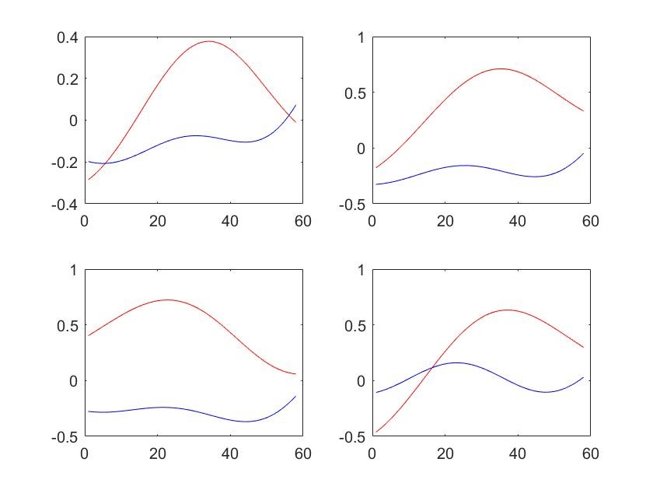
Figure 3.2: HbO2 Time traces extracted from the data in Matlab for the LA task in red and the HA task in blue for channels 1 and 2 on the left hemisphere (top row) and channels 3 and 4 on the right hemisphere (bottom row).

Chapter 5

Conclusion

Lorem ipsum dolor sit amet, consectetuer adipiscing elit. Ut purus elit, vestibulum ut, placerat ac, adipiscing vitae, felis. Curabitur dictum gravida mauris. Nam arcu libero, nonummy eget, consectetuer id, vulputate a, magna. Donec vehicula augue eu neque. Pellentesque habitant morbi tristique senectus et netus et malesuada fames ac turpis egestas. Mauris ut leo. Cras viverra metus rhoncus sem. Nulla et lectus vestibulum urna fringilla ultrices. Phasellus eu tellus sit amet tortor gravida placerat. Integer sapien est, iaculis in, pretium quis, viverra ac, nunc. Praesent eget sem vel leo ultrices bibendum. Aenean faucibus. Morbi dolor nulla, malesuada eu, pulvinar at, mollis ac, nulla. Curabitur auctor semper nulla. Donec varius orci eget risus. Duis nibh mi, congue eu, accumsan eleifend, sagittis quis, diam. Duis eget orci sit amet orci dignissim rutrum.

Lorem ipsum dolor sit amet, consectetuer adipiscing elit. Ut purus elit, vestibulum ut, placerat ac, adipiscing vitae, felis. Curabitur dictum gravida mauris. Nam arcu libero, nonummy eget, consectetuer id, vulputate a, magna. Donec vehicula augue eu neque. Pellentesque habitant morbi tristique senectus et netus et malesuada fames ac turpis egestas. Mauris ut leo. Cras viverra metus rhoncus sem. Nulla et lectus vestibulum urna fringilla ultrices. Phasellus eu tellus sit amet tortor gravida placerat. Integer sapien est, iaculis in, pretium quis, viverra ac, nunc. Praesent eget sem vel leo ultrices bibendum. Aenean faucibus. Morbi dolor nulla, malesuada eu, pulvinar at, mollis ac, nulla. Curabitur auctor semper nulla. Donec varius orci eget risus. Duis nibh mi, congue eu, accumsan eleifend, sagittis quis, diam. Duis eget orci sit amet orci dignissim rutrum.

References

[1] I. P. Kan and S. L. Thompson-Schill, “Effect of name agreement on prefrontal activity
during overt and covert picture naming,” Cognitive, Affective, & Behavioral
Neuroscience, vol. 4, no. 1, pp. 43–57, 2004.

[2] J. G. Snodgrass and M. Vanderwart, “A standardized set of 260 pictures: Norms for name
agreement, image agreement, familiarity, and visual complexity.,” Journal of
experimental psychology: Human learning and memory, vol. 6, no. 2, p. 174, 1980.

[3] S. C. Bunce, K. Izzetoglu, H. Ayaz, P. Shewokis, M. Izzetoglu, K. Pourrezaei, and B.
Onaral, “Implementation of fnirs for monitoring levels of expertise and mental
workload,” in Foundations of Augmented Cognition. Directing the Future of Adaptive
Systems, D. D. Schmorrow and C. M. Fidopiastis, Eds., Berlin, Heidelberg: Springer
Berlin Heidelberg, 2011, pp. 13–22.

[4] L. Ferreri, J. Aucouturier, M. Muthalib, E. Bigand, and A. Bugaiska, “Music improves
verbal memory encoding while decreasing prefrontal cortex activity: An fnirs study,”
Frontiers in Human Neuroscience, vol. 7, p. 779, 2013.

[5] S. L. Thompson-Schill, I. P. Kan, and R. T. Oliver, “Functional neuroimaging of semantic
memory,” Handbook of functional neuroimaging of cognition, vol. 2, pp. 149–190,
2006.

[6] S. L. Thompson-Schill, “Neuroimaging studies of semantic memory: Inferring “how”
from “where”,” Neuropsychologia, vol. 41, no. 3, pp. 280–292, 2003.

[7] S. L. Thompson-Schill, M. D’Esposito, G. K. Aguirre, and M. J. Farah, “Role of left
inferior prefrontal cortex in retrieval of semantic knowledge: A reevaluation,”
Proceedings of the National Academy of Sciences, vol. 94, no. 26, pp. 14 792–14 797,
1997.

[8] A. D. Wagner, E. J. Par´e-Blagoev, J. Clark, and R. A. Poldrack, “Recovering meaning:
Left prefrontal cortex guides controlled semantic retrieval,” Neuron, vol. 31, no. 2,
pp. 329–338, 2001.

[9] J. D. Gabrieli, J. E. Desmond, J. B. Demb, A. D. Wagner, M. V. Stone, C. J. Vaidya, and
G. H. Glover, “Functional magnetic resonance imaging of semantic memory processes
in the frontal lobes,” Psychological Science, vol. 7, no. 5, pp. 278–283, 1996.

[10] S. L. Thompson-Schill, D. Swick, M. J. Farah, M. D’Esposito, I. P. Kan, and R. T.
Knight, “Verb generation in patients with focal frontal lesions: A
neuropsychological test of neuroimaging findings,” Proceedings of the National
Academy of Sciences, vol. 95, no. 26, pp. 15 855–15 860, 1998.

[11] A. Kleinschmidt, H. Obrig, M. Requardt, K.-D. Merboldt, U. Dirnagl, A. Villringer, and
J. Frahm, “Simultaneous recording of cerebral blood oxygenation changes during
human brain activation by magnetic resonance imaging and near-infrared
spectroscopy,” Journal of Cerebral Blood Flow & Metabolism, vol. 16, no. 5, pp.
817–826, 1996, PMID: 8784226.

[12] M. Ferrari and V. Quaresima, “A brief review on the history of human functional near-
infrared spectroscopy (fnirs) development and fields of application,” Neuroimage,
vol. 63, no. 2, pp. 921–935, 2012.

[13] N. Naseer and K.-S. Hong, “Fnirs-based brain-computer interfaces: A review,” Frontiers
in Human Neuroscience, vol. 9, p. 3, 2015.

[14] G. Strangman, D. A. Boas, and J. P. Sutton, “Non-invasive neuroimaging using near-
infrared light,” Biological psychiatry, vol. 52, no. 7, pp. 679–693, 2002.

[15] H.-J. Hwang, J.-H. Lim, D.-W. Kim, and C.-H. Im, “Evaluation of various mental task
combinations for near-infrared spectroscopy-based brain-computer interfaces,”
Journal of Biomedical Optics, vol. 19, no. 7, p. 077 005, 2014.

